DoubleClipperSwitch V1.0

GJCAMANN © 2014

This allows you to conveniently add a clipper circuit to an existing PCB or VERO layout. Using an ON-OFF-ON solder terminal switch this allow the selection of clipper set 1, no clipper or clipper 2. One half of the board is one clipper, the other half, the other. For convenience there are two low pads -1 and -2 and one high pads +1. Connect the high pads to the input to your volume pot and the low pads to ground. Each clipper block has 3 terminals with 1 annode pad and 2 cathode pads. This will support using MOSFETs as clippers. For MOSFET use the source as cathode and the gate and drain as cathode, this works best with the double clipper and a schottsky diode in series to prevent the body diode from activating.

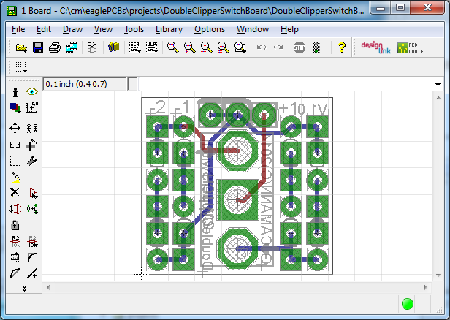 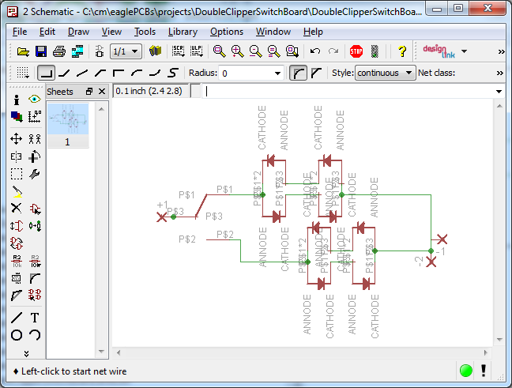

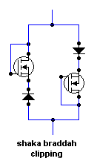

THERE IS NO WARRANTY FOR THIS DESIGN, TO THE EXTENT PERMITTED BY APPLICABLE LAW. THE DESIGN IS PROVIDED “AS IS” WITHOUT WARRANTY OF ANY KIND, EITHER EXPRESSED OR IMPLIED, INCLUDING, BUT NOT LIMITED TO, THE IMPLIED WARRANTIES OF MERCHANTABILITY AND FITNESS FOR A PARTICULAR PURPOSE. THE ENTIRE RISK AS TO THE QUALITY AND PERFORMANCE OF THE DESIGN IS WITH YOU. SHOULD THE DESIGN PROVE DEFECTIVE, YOU ASSUME THE COST OF ALL NECESSARY SERVICING, REPAIR OR CORRECTION.

Licensed under <http://creativecommons.org/licenses/by-sa/4.0/deed.en_US>